केंद्रीय विद्यालय विकासपुरी  हस्तसाल गाँव उत्तम नगर (पाली -2)  नई दिल्ली-110059  – 011-25376589,25352668  ई.मेल - kvvikaspuri59@gmail.com  वेबसाइट - www.kvvikaspuri.edu.in |  | KENDRIYA VIDYALAYA VIKASPURI  Hastsal Village Uttam Nagar (Shift-2)  New Delhi – 110059  – 011-25376589,25352668  E.Mail - kvvikaspuri59@gmail.com  Website - www.kvvikaspuri.edu.in
CBSE School Code – 65565, Affiliation No. – 2700029, Station Code – 239, KV Code – 1451

NO.F /KVVP/2022-23 (II- SHIFT) Date: - 23/06/2022
PROVISIONAL ADMISSION LIST (2022-23)
Category –V (List NO. 1)
The following candidates have been provisionally selected by draw of lots held on 29.04.2022 for Admission in Class-I (Session2022-23) Under V Category. Their admission is subject to production of relevant original documents at the time of admission.

Parents are requested to report with their ward w.e.f. 24.06.2022 between01:00 pm to 03:00 pm in Room no. 10 according to given schedule.
Post-Lottery Number | Date of reporting | Time
1/WL50- 35/WL84 | 24.06.2022 | 01:00 pm to 03:00 pm

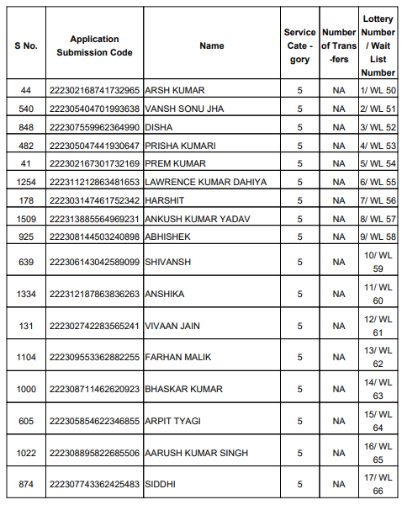
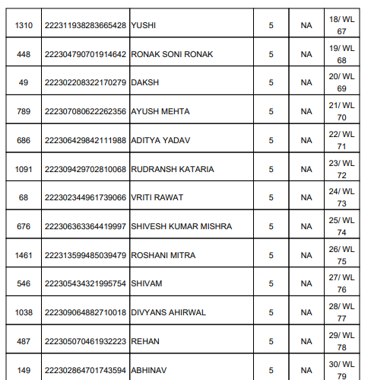
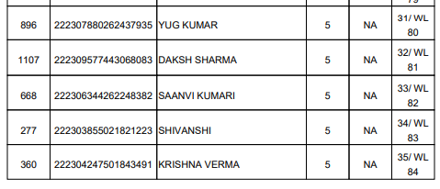
Note: Parents are requested to bring their child at the time of admission.

I/C ADMISSION CHAIRMAN VMC PRINCIPAL

